Augmented reality technologies for biodiversity education – a case study
Jens Ingensand,  Maryam Lotfian,  Sarah Composto,  University of Applied Sciences Western Switzerland/GIS-lab/  insit Institute  Route de Cheseaux 1  1401 Yverdon-les-Bains,  Switzerland  {jens.ingensand, maryam.lotfian, sarah.composto}@heig-vd.ch | Olivier Ertz,  Mathias Oberson,  Simon Oulevay,  Mélanie Da Cunha,  University of Applied Sciences Western Switzerland/MEI Institute  Avenue des Sports 20  1401 Yverdon-les-Bains,  Switzerland  {olivier.ertz, mathias.oberson, simon.oulevay, melanie.dacunha}@heig-vd.ch | David Piot  Lausanne University of Teacher Education, Avenue de Cour 33  1007 Lausanne  & University of Geneva  p15014@hepl.ch

Abstract
Mobile technology is developing fast in recent years, and the price of mobile devices is dropping and becoming affordable for the majority of people. As a result, the use of smartphones and tablets is increasing at a rapid rate, even among children. Nowadays, in many countries, smartphones are being used at school as advanced teaching tools to motivate children to learn better. One of the recent examples is the utilization of Augmented Reality mobile applications for educational purposes. This paper is presenting an AR mobile application, which is encouraging children to learn about biodiversity. The application was evaluated during a field trip with 15 pupils of around 10 years of age, and the results illustrate the behavior of the pupils using the application, and the potential of the app to create a connection between the students and the nature. Moreover, analyzing the time the pupils spent on the application demonstrates a motivation among the pupils to find out about various species through a combination of an outdoor activity and a mobile application.
- Introduction
Technology has become an inseparable part of our lives, especially during the last decades. Among all the technological products, the use of smartphones is significantly increasing. Moreover, in recent years, smartphones and tablets are being used in schools for educational purposes (Kyriakides and Meletiou-mavrotheris, 2016)(Lu and Liu, 2015)(Pyykkönen et al., 2013)(Coimbra, Cardoso and Mateus, 2015). Augmented Reality (AR), a technology that combines the real world with virtual objects (Azuma, 1997), has been utilized in many mobile applications for various purposes, among which the use of AR in education is drawing the attention of researchers. However, there are few researches reporting the use of AR application towards learning ecological knowledge.

Due to the essential role, that biodiversity plays in our lives, particularly its impact on human-wellbeing, it is extremely important to make the children acquainted with this concept from early ages at school. The idea is not just teaching them in theory, yet in addition taking them to the nature and helping them understand the special link between different species and human beings.
Accordingly, in this paper, we are presenting a mobile AR application called BioSentiers, with the objective of encouraging children to learn about biodiversity. In the following sections, we discuss the utilization of AR in education, followed by a project description. From that point, the hypotheses and results of a first test of the application with pupils of around 10 years old is presented. Finally, we will present our conclusions and perspectives for future work.

- Augmented reality applications for educational purposes
The term Augmented Reality (AR) was first introduced in 1990 by Tom Caudell (Coimbra, Cardoso and Mateus, 2015) (Akçayır and Akçayır, 2017), a former Boeing researcher, as a tool for airline training. Essentially, AR is a technology that incorporates digital information into the real world, increasing the capabilities of human perception by means of virtual objects that contain information not accessible by human senses(Azuma, 1997). AR technology has been used in several applications, such as medical visualization, military operations, annotation, entertainment, etc. (Azuma, 1997). However, one of its main applications, especially in recent years, is the utilization of AR in education.

The potentiality of AR technology to enhance student learning has been explored in a large number of scientific studies (Radu, 2014). The possibility of observing virtual objects in the real world, helps students to better understand the concepts that are difficult for them to visualize (Akçayır and Akçayır, 2017).

In a literature review of advantages and challenges of AR in education, Murat & Gokçe Akçayır (Akçayır and Akçayır, 2017), have classified the advantages of AR in education into four categories: “learner outcomes, pedagogical contributions, interaction, and other”. The majority of studies have illustrated that the use of AR in education results in “Enhancing learning achievement”, a subcategory of “Learner Outcomes” (Akçayır and Akçayır, 2017). For instance, Lu and Lui (Lu and Liu, 2015) have reported that students showed a satisfactory opinion towards AR learning techniques in marine education. Moreover, they have concluded that learning through playing can improve students learning performances. Accordingly, the use of this technology in education leads to an increase in students’ motivation to learn, and improves their imagination skill.

Although AR can be considered an advanced and convenient tool when it is used in education, in the absence of a well-designed interface, it can be very difficult and complicated to use for students (Squire and Jan, 2007). Therefore, the design and simplicity of an AR application is of utmost importance, especially when it comes to student learning.

Despite the fact that a considerable number of researches have reported the use of AR in education, such as in mathematics, history, medicine, etc., there are to the best of our knowledge only few addressing the use of AR in nature-related education.

One example is a project called Nature AR. NatureAR (Alakärppä et al., 2017) has been developed by researchers from the University of Lapland in Finland and is related to the use of nature elements in AR mobile application. In their work marker-based AR approach has been used. Marker-based AR applications are based on machine vision techniques. The marker (such as a QR code, an image, or even a physical object) is being detected, using the camera of a portable device, and then the AR application overlays the marker with the digital information(Siltanen, 2012). In the NatureAR project, nature and printed markers of different species were hidden in several locations of the research area, and the pupils were asked to find them. After finding and scanning a marker, two 3D models were displayed on the screen, and pupils were required to choose the right model, using the marker as a hint.

- The BioSentiers project
BioSentiers is a project developed by the School of Engineering and Management of Yverdon-les-Bains (HEIG-VD), especially by the Media Engineering Institute (MEI) and the Territorial Engineering Institute (insit) in collaboration with the University of Teacher Education Vaud and the local school. The aim of this project is to increase pupils’ understanding about biodiversity and conservation. For this purpose a path between the train station of Yverdon-les-Bains and Champ Pittet, a nature reserve was created and data about biodiversity was collected along the path.

Figure 1: Screenshot of the AR mode of BioSentiers and the 2D map
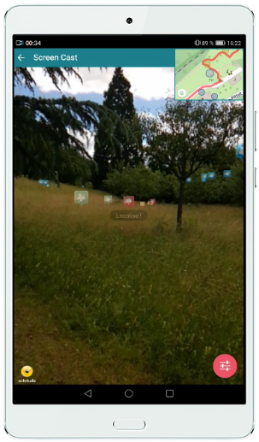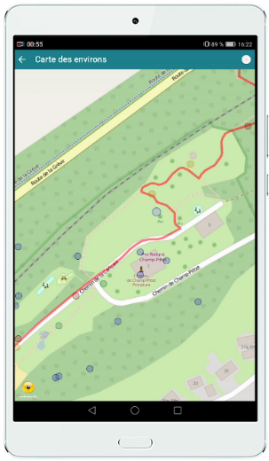

The main objective of BioSentiers is to connect 9-12 y.o. pupils with the nature, and motivate them to learn about biodiversity.

In this project, pupils observe natural space through the camera of a portable device (tablet or smartphone), with the virtual elements representing biodiversity Points of Interest (POI) overlaying on the screen.

By tapping the screen on each POI, pupils are guided about their distance (in meters) from the real object. After they get close enough to the object, they can tap the screen on the virtual object, and a modal opens containing an image and information regarding the species (Figure 2). Therefore, pupils can compare the image with the real object, and enhance their knowledge about different species. If a pupil sees the virtual object in the real world he needs to confirm having identified the object. In this way, the application can be entertaining, while at the same time keeping its fundamental goal.

Figure 2: Information page of the species
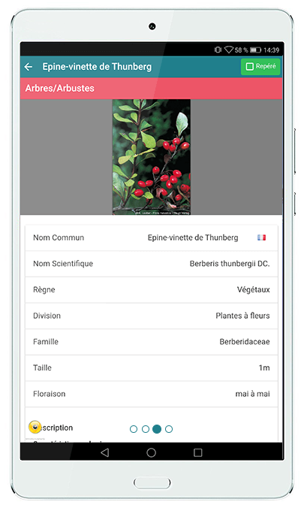

- Hypotheses

We wanted to find out how the BioSentiers application is used by pupils, and also if pupils can make the connection between the real world and the virtual content displayed on their screens. The principal hypotheses that we wanted to address in order to discuss this overarching goal were:

H1: There are different strategies to identify species using the application. Pupils are for instance either guided by nature (e.g. visible species in the real world) or by technology (e.g. visualization of species in augmented reality)
H2: Pupils compare the virtual object with the object in the real world before confirming that they have identified the species in the real world.
H3: There is a learning curve regarding the identification of species. A species that has once been identified is more quickly identified the second time.
H4: Pupils switch between the AR view of the application and the 2D map to improve their orientation.

- Experiment setting

A class trip was held in November 2017 to test the application with 15 ten year old pupils. Due to the fact that few species were visible in November, a scenario that involved only trees was configured. During the experiment the goal was to collect relevant data related to the use of the mobile application. On this class trip, pupils used the BioSentiers mobile application either alone or in groups of two during about 15 minutes in a park in Yverdon-les-Bains. None of the pupils had used the BioSentiers application before.

In order to analyze the utilization of the BioSentiers application, some pupils were filmed during the trip.

Moreover the screen of each mobile device was recorded and events related to the utilization of the application were stored in the database of the application, e.g.: when and where the application was started, paused or resumed, the augmented reality interface was started or closed, the reference map was opened or closed, the modal related to a species of a point of interest is opened or closed, or when a user has confirmed that he has identified the point of interest in the “real world”. Based on the videos, the screencasts and the cleaned log database, several responses we were able to discuss the hypotheses.

- Results

H1: There are different strategies to identify species using the application. Pupils are for instance either guided by nature (e.g. visible species in the real world) or by technology (e.g. visualization of species in augmented reality)

In our data we could clearly see that some pupils took the time to identify the points of interest and to compare the species in the real-world with the virtual file. On the other hand some pupils tried to find as many trees as possible (without looking at the species in the real world). These pupils compared the BioSentiers application with the well-known Pokémon Go AR application.

In general, pupils kept their eyes near the screen and were not always looking where they were going. Thereby the surrounding nature was less considered. On average pupils only spent 11.5% of the time looking at the environment while during 88.5% of the time they were looking at the screen. Since pupils rarely looked at the environment and where they were going, they sometimes got hit by tree branches and tripped on broken branches on the ground. Furthermore, they usually followed the instruction on the screen. For instance, when the pupils saw a point of interest in front of a tree in the AR interface, they immediately thought that the point of interest indicated this particular tree; only after a while the pupils realized that it was a different tree indicated in the AR interface.

All pupils became more excited as they moved towards a tree that was visible in the BioSentiers application. In the application the points of interest become bigger as the user is moving towards them and smaller as he is moving away. During the experiment, only a few pupils noted the change of size of the points on the screen. Another way to understand the distance to the points of interest is to click them. If the user is too far, the distance to the point of interest is displayed. During the excursion, all pupils used this functionality to identify the distance to the points of interest.

In the park there were many trees; therefore the GPS signal was not always very good. As the BioSentiers application uses GPS to locate the users position, it could occur that the points of interest were not displayed on the screen for a few seconds. Some pupils therefore had some difficulties to correctly use the augmented reality interface. These pupils saw a point of interest on the screen and moved toward it. A couple of seconds later, as the pupils were near a tree they got lost and searched other points of interest on the screen without having identified the initial tree in the real world.

H2: Pupils compare the virtual object with the object in the real world before confirming that they have identified the species in the real world.

Some pupils were very conscientious (e.g. they read all the information in the modal), especially if there was an adult close to them. Each pupil or group of pupils spent between 10% and 39% of the total excursion time reading the information of the modal and searching each tree in the real world. In order to identify the tree described by the modal, pupils mostly used the height information and the picture of the tree or the leaves of the tree. They rarely used other information, such as the characteristics of the bark. Although some pupils were more conscientious than others, they quickly searched the tree in the real world. Furthermore, the time spent reading a modal generally decreased during the excursion period. This fact could be related to the consideration that the structure of the modal always stays the same.

H3: There is a learning curve regarding the identification of species. A species that has once been identified is more quickly identified the second time.

Each pupil or group of pupils saw between one and four different species while they were using the application. Due to the fact that the same species can be found at several different locations, some pupils saw the same species several times. In this case pupils quickly realized that they had already seen the species and the modal was therefore quickly closed.

H4: Pupils switch between the AR view of the application and the 2D map to improve their orientation.

In the augmented reality interface, there is a small map at the top right of the screen for orientation purposes. If a user clicks on this small map, a larger map is opened in full screen.

One group of pupils at first used the larger map to direct themselves towards the different points of interest (instead of using the AR view). This group took a considerable amount of time to go find the first point of interest. Later this group used the augmented reality interface. All other pupils mostly used the augmented reality interface (the large map was only opened 7 times by all pupils)

A possible interpretation of this result is that the AR view is more efficient and intuitive for finding points of interest than a 2D map.

- Conclusions and perspectives
Augmented reality applications for biodiversity are an interesting tool for educational purposes. The BioSentiers application that we have developed allows pupils to discover different species and to learn about their environment.

We wanted pupils to understand the relationship between the virtual content and the species in the real world. One interesting finding in this context was the fact that pupils mostly look at their mobile devices and less at the environment. This finding however could be related to the fact that the pupils never had used the application before and that it takes time to get used to it. Another interesting finding is the fact that wayfinding using a 2D map appears to be less efficient than wayfinding using an AR view.

Today the BioSentiers application does not verify if a user really has identified the right species in the real world (and did not simply click on the button to validate that he has identified the species). Therefore we want to implement the functionality to take a picture of the species and to allow for discussing the pictures later in class. Another functionality that we want to implement is the possibility to introduce new points of interest and to modify existing points of interest (in case they are not accurate anymore).

In the future we want to test the application during spring or summer in order to include other species such as flowers and birds in the experience. Another important consideration is the utilization of the application over time and to investigate (e.g. using a mobile eye-tracker) if users adapt their behavior and their strategies.

References
- Akçayır, M. and Akçayır, G. (2017) ‘Advantages and challenges associated with augmented reality for education: A systematic review of the literature’, Educational Research Review, 20, pp. 1–11. doi: 10.1016/j.edurev.2016.11.002.

- Alakärppä, I. et al. (2017) ‘Using nature elements in mobile AR for education with children’, Proceedings of the 19th International Conference on Human-Computer Interaction with Mobile Devices and Services - MobileHCI ’17, (September), pp. 1–13. doi: 10.1145/3098279.3098547.
- Azuma, R. T. (1997) ‘Survey of Augmented Reality’, pp. 355–385.

- Coimbra, M. T., Cardoso, T. and Mateus, A. (2015) ‘Augmented Reality: An Enhancer for Higher Education Students in Math’s Learning?’, Procedia Computer Science. Elsevier Masson SAS, 67(Dsai), pp. 332–339. doi: 10.1016/j.procs.2015.09.277.
- Kyriakides, A. O. and Meletiou-mavrotheris, M. (2016) ‘Mobile technologies in the service of students ’ learning of mathematics : the example of game application A . L . E . X . in the context of a primary school in Cyprus’, pp. 53–78. doi: 10.1007/s13394-015-0163-x

- Lu, S. J. and Liu, Y. C. (2015) ‘Integrating augmented reality technology to enhance children’s learning in marine education’, Environmental Education Research, 21(4), pp. 525–541.doi: 10.1080/13504622.2014.911247.
- Pyykkönen, M. et al. (2013) ‘Activity Pad : Teaching Tool Combining Tangible Interaction and Affordance of Paper’, pp. 135–144.

- Radu, I. (2014) ‘Augmented reality in education : a meta-review and cross-media analysis’, pp. 1533–1543. doi: 10.1007/s00779-013-0747-y.
- Siltanen, S. (2012) ‘Theory and applications of marker based augmented reality’, (January 2012).
- Squire, K. D. and Jan, M. (2007) ‘Mad city mystery: Developing scientific argumentation skills with a place-based augmented reality game on handheld computers’, Journal of Science Education and Technology, 16(1), pp. 5–29. doi: 10.1007/s10956-006-9037-z.

